CIS 4911 – Senior Project
Tractouch's iBLESS
User Manual

Team Members: Luis Miguel Carrillo
Mentor: Jaime Borras
02/02/2015
COPYRIGHTS AND TRADEMARK INFORMATION

This work is entirely done by Luis Miguel Carrillo unless written otherwise.

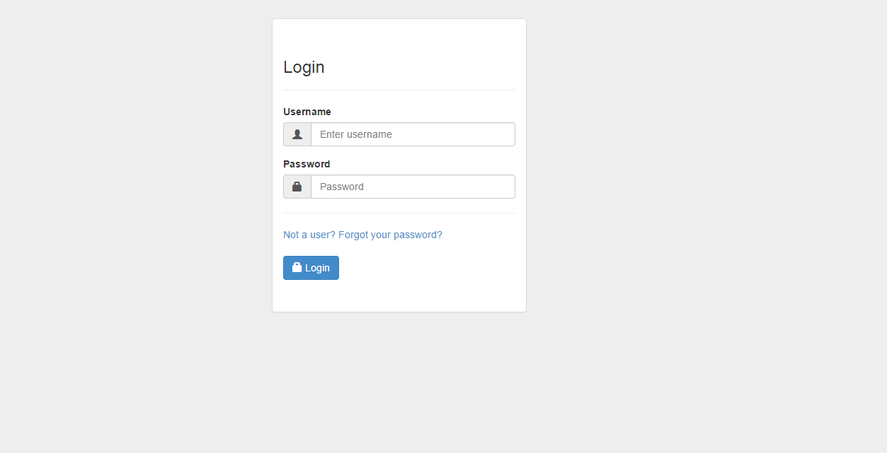
Login Screen

The user inputs their username and password and presses enter or clicks login. Additionally, the user can register by pressing “Not a user?” and they can retrieve their password by pressing “Forgot your password?”

Register Screen

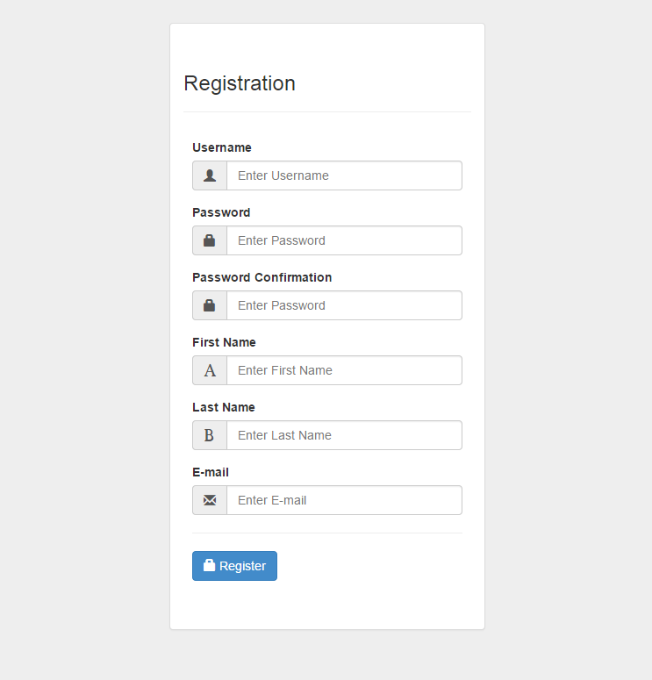

The user inputs their username, password, password confirmation, first name, last name, and e-mail and presses enter or clicks register.

Forgot Password

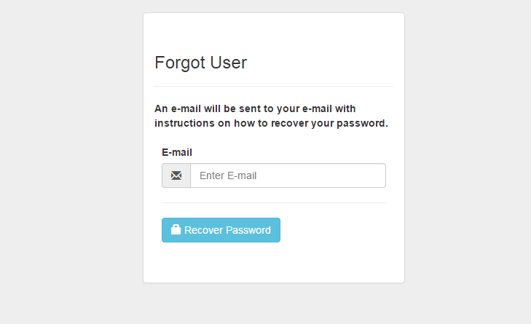
The user submits the e-mail and presses enter or clicks recover password.

User Management

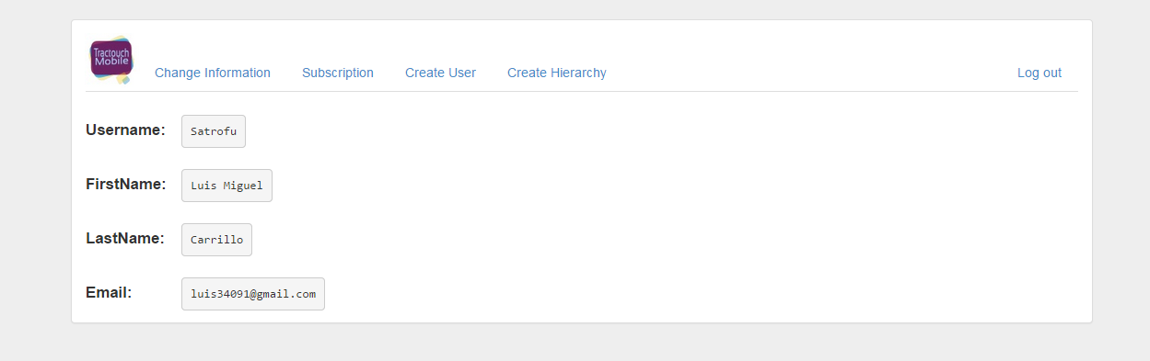
The user can click the logo in order to return to user management, they can also click change information in order to change their password, lastname, etc... as well as click subscription, create user, and create hierarchy.

Subscription

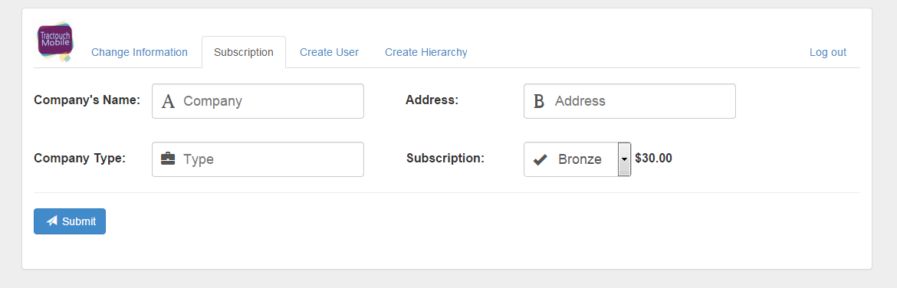
The user inputs the company name, address, company type, and the subscription type, then presses enter or clicks submit.

Create User

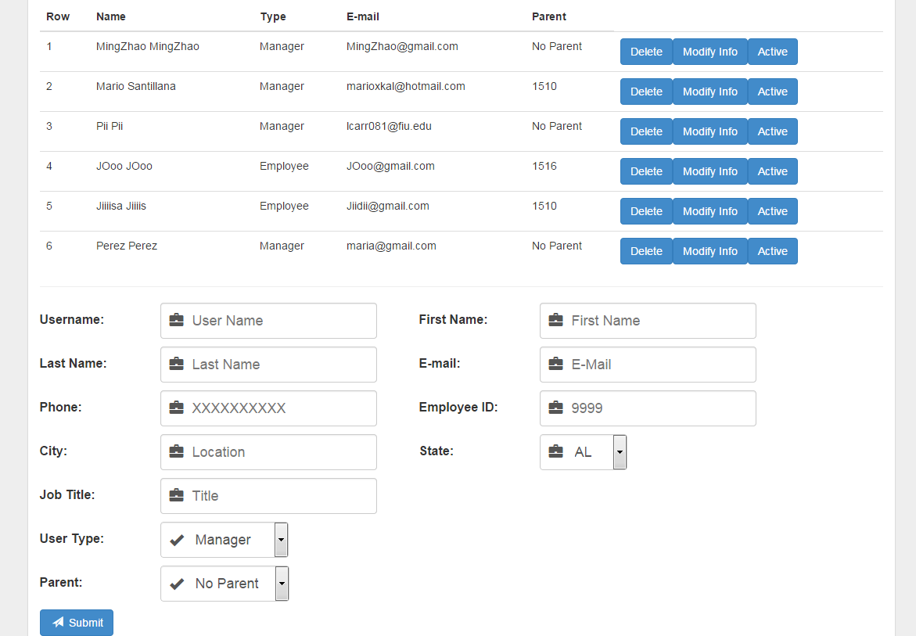
The user inputs username, first name, last name, phone, e-mail, employee ID, city, state, job title, user type (assuming hierarchy already created), and parent, then the user presses enter or clicks submit. The user can also modify the info by clicking modify infor or make a user inactive or active by pressing the active button. Finally, the user can delete users by pressing the corresponding delete button.

Modify Info

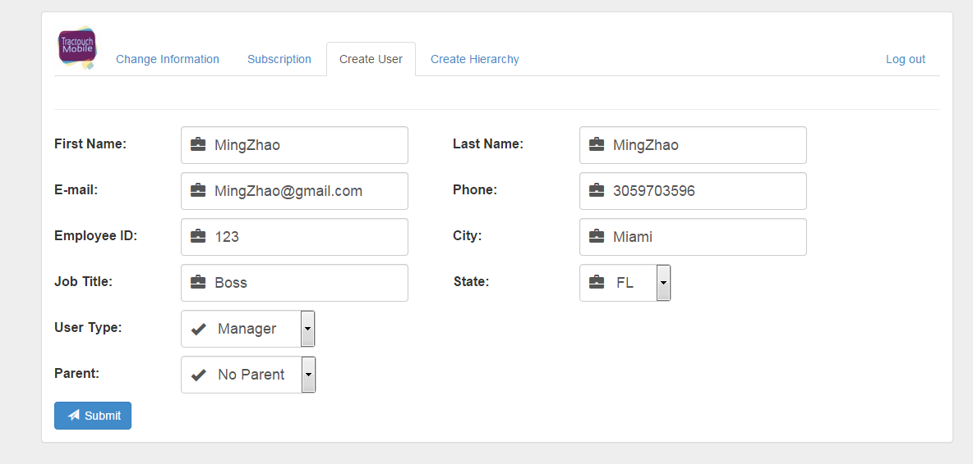
The user inputs first name, last name, e-mail, phone, employee ID, city, job title, state, user type, and parent, then clicks submit or presses enter.

Create Hierarchy

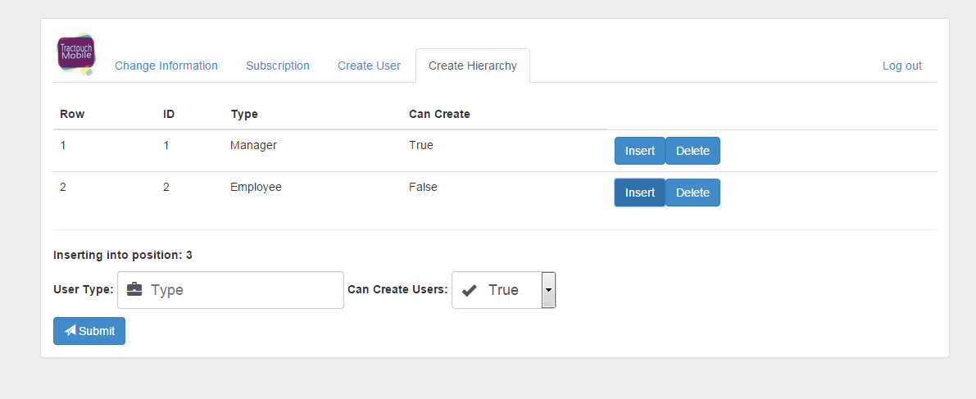
The user clicks insert to insert a new role and inputs user type and can create users, then clicks submit or presses enter. Also, if deletion is needed, the user clicks the corresponding delete button.

